HLA B27-Positive Ankylosing Spondylitis with Multiple Joint Damage in a Professional Soccer Player: A History of Successful Return to Sport

Eduard Bezuglov ^{1,2,3}, Maria Shoshorina ¹, Talibov Oleg ^{3,10}, Artemii Lazarev ^{1,3,4}, Yuri Kuklin ⁵, Kamila Kubacheva ⁶, Vladimir Khaitin ^{7,8}, Waśkiewicz Zbigniew ^{1,9}
¹ Sechenov First Moscow State Medical University (Sechenov University), Moscow, Russia;
² Federal Research and Clinical Center of Sports Medicine and Rehabilitation of Federal Medical Biological Agency, Moscow, Russia;
³ High Performance Sport Laboratory, Moscow Vitte University, Moscow, Russia; E. Bezuglov e.n.bezuglov@gmail.com,
⁴ A.I. Burnazyan Federal Medical and Biophysical Center; A. Lazarev lazarevartemii@yandex.ru
⁵ FC «Lokomotiv» Moscow, Russia; Y. Kuklin kuklin@fclm.ru
⁶ Saint-Petersburg State Public Institution «City Hospital №40», Saint-Petersburg, Russia; K. Kubacheva kamila_kubacheva@mail.ru
⁷ Pavlov First Saint-Petersburg State Medical University, Saint-Petersburg, Russia;
⁸ FC «Zenit», Saint-Petersburg, 197341, Russia; V. Khaitin khaitinvladimir@gmail.com
⁹ Institute of Sport Science, Jerzy Kukuczka Academy of Physical Education, Katowice, Poland;
¹⁰ Moscow State University of Medicine and Dentistry, Moscow, Russian Federation; O. Talibov oleg.talibov@gmail.com

Corresponding author:

Keywords: ankylosing spondylitis, soccer, spondyloarthritis

Abstract
Ankylosing spondylitis is a relatively rare severe disease of the musculoskeletal system and other organ systems associated with chronic inflammation. The frequency of occurrence is up to 1.8% of the population. Most often, the knee joints, sacroiliac joints, and spine are affected. Extraarticular manifestations, such as damage to the eyes, intestines, etc., are also sometimes found. As a rule, this disease manifests itself in young adulthood. Without adequate treatment, the disease progresses rapidly and dramatically reduces physical activity.
The case presented describes the clinical case of a young professional soccer player with the diagnosis of ankylosing spondylitis, who was able to return to regular training after 14 months of treatment and continuing to play sports professionally amid supportive therapy.
Treatment of the disease is currently based on the use of NSAIDs, analgesics, DMARDs, TNFalpha inhibitors and Anti-IL17. Local glucocorticoids can be given for symptomatic relief.
In the vast majority of cases, such a diagnosis makes it impossible to engage in game sports even at a semi-professional level. There are no reported cases of returning to regular training activity for professional football players in the available literature.
Further monitoring is needed and the creation of a unified database of athletes with similar diseases to unify treatment protocols for patients with initially very high levels of physical activity.

Introduction
Ankylosing spondylitis is a synonym for radiographic axial spondyloarthritis, which, along with non-radiographic axial spondyloarthritis (which include less severe forms and early stages of ankylosing spondylitis), is considered a broader disease of axial spondyloarthritis. [1]
This is a relatively rare severe disease of the musculoskeletal system and other organ systems, which is based on prolonged inflammation of the spine and various joints. The most commonly affected joints are knee joints, sacroiliac joints, ankles and spine. Extraarticular manifestations, such as lesions of the eyes, intestines, etc., are also often found. [2]
Although the exact cause of the disease is unknown, the literature describes in detail the association of ankylosing spondylitis with HLA B27. [2-5]

As a rule, this disease manifests itself in young adulthood. Most often it occurs among men aged 25-35 years [5,6] and in most cases is accompanied by a significant restriction of physical activity [7]
Diagnosis of the disease is based on a combination of factors, among which the clinical picture, positive HLA B27, an increase in systemic markers of inflammation (ESR, CRH, ASO) and the data of instrumental methods of investigation are most important, among which the most preferred in the early stages is MRI, which allows in the early stages identify inflammation in large joints. [1,8]
The treatment of this pathology is currently based on therapy, which may include NSAIDs, analgesics, DMARDs, TNFalpha inhibitors, Anti-IL17, which allows to achieve a good clinical effect and prolonged remission [9]. Local glucocorticoids can be given for symptomatic relief.
Professional sports have special requirements for the musculoskeletal system and are accompanied by frequent post-exercise inflammation of the muscles, tendons, bones and joints. In the vast majority of cases, such a diagnosis makes it impossible to engage in sports on a professional level.
The case presented describes the clinical case of a young football player who played for the youth team of his country, who was able to return to regular training after 14 months of treatment and rehabilitation training.

Patient information
In April 2018, a 19-year-old professional football player (170 cm height, 65 kg weight, BMI 22.5) without a family history of inflammatory joint diseases, playing football since the age of six and playing for the youth team of one of the leading Russian football clubs, as well as the youth team, turned to the team’s doctor.
The main complaints were pain in the right ankle joint that arose without a connection with the injury and gradually intensified over several days. The joint was normal form, good mobility.
During the 5 years prior to the treatment, he conducted medical tests twice a year with other players and there were no signs of inflammation or quantitative changes in blood tests.
Previously, a player during the year occasionally complained of discomfort in the ankle joints, sacroiliac area and symphysis, which did not limit his regular training activity (RTA) and did not require therapy.

Clinical findings
In April 2018, considering the negative dynamics of symptoms on the background of standard treatment of sports injuries for 14 days with limited physical activity (NSAID: ibuprofen 200 mg 2 times a day, cryotherapy, joint taping), differential diagnostics began with systemic diseases, including arthritis. General examination was unremarkable, the joints were mobile, regular in shape, without swelling. Regional lymph nodes of normal sizes. Body temperature was normal during the onset of the disease.
After a diagnostic search, ankylosing spondylitis was diagnosed. The test confirming the diagnosis was a genetic analysis that showed HLA B27 +.
During a few weeks after the appearance of pain in the ankle joint, pain syndrome has appeared in the knee joint, lumbar and thoracic spine, weakness, calf muscle hypotrophy, serum concentration of inflammatory markers in the blood increased significantly (ESR - 60, CRP - 50).
BASDAI index was used for this patient at the first time (=5,9 points).

Timeline
Date of manifestation: April 2018
Release date in the general group: August 2019
Outside the general group 16 months
After 6 months of therapy, the expressed clinical picture changed to stable, but by the 10th month of therapy, destabilization occurred. After the change in therapy, the clinical picture stabilized again.
MRI Assessment
Considering the expressed pain syndrome, an MRI of the ankle joint was the main method of instrumental diagnostics (Figures 1,2). X-ray of the thoracic and lumbar spine, X-ray of the hip, ankle joints- without any features. On MRI of the sacroiliac joints – signs of the sacroiliitis right side (Figure3).
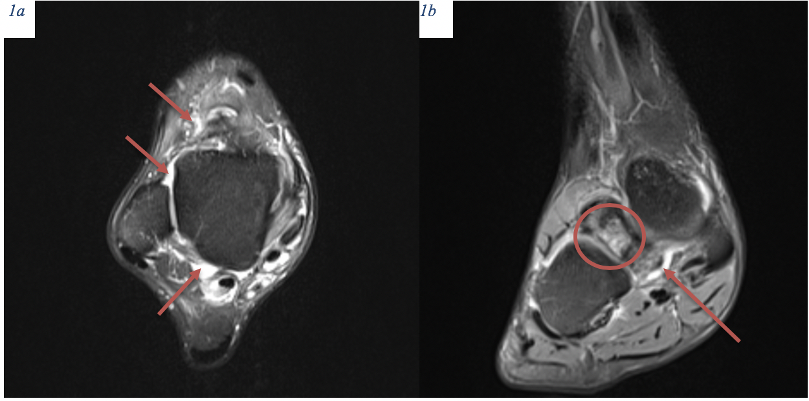
Figure 1. MRI of the right ankle in dynamic. 1a, 1b - 21.06.2018. Reactive bone marrow edema in the form of zones of increase in intensity of the MR-signal on PD WI FAT SAT (proton density weighted image fat saturation) in adjacent sections of the calcaneus and scaphoid bone, surrounding fiber is edematous, including the region of the subtalar sinus, synovitis in the ankle joint.

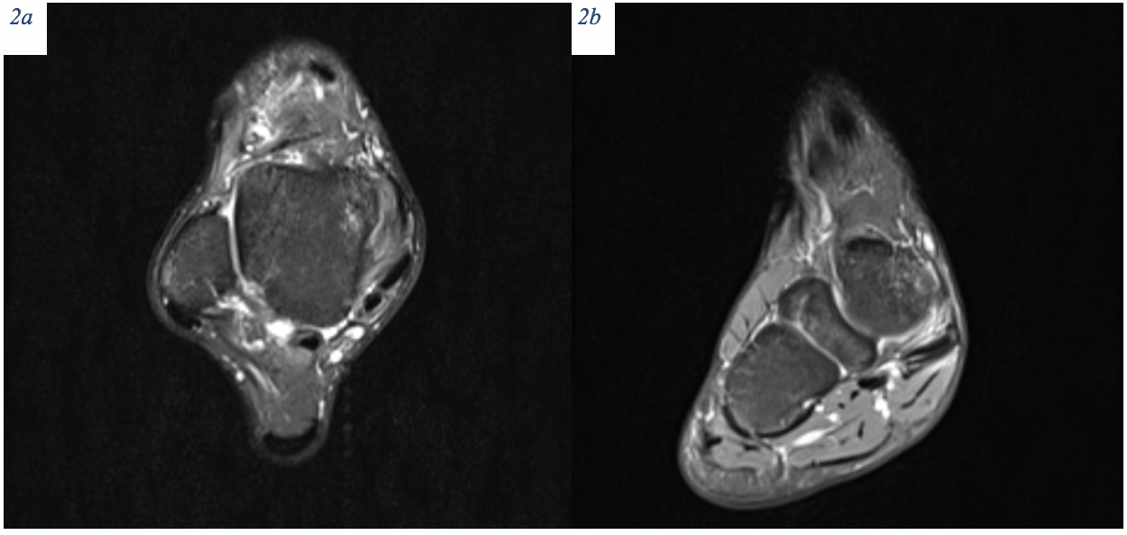

Figure 2. MRI of the right ankle in dynamic. 2 a, 2b – 09.04.2020. Reactive bone edema and sclerosis of the bone marrow, signs of the synovitis are much less.

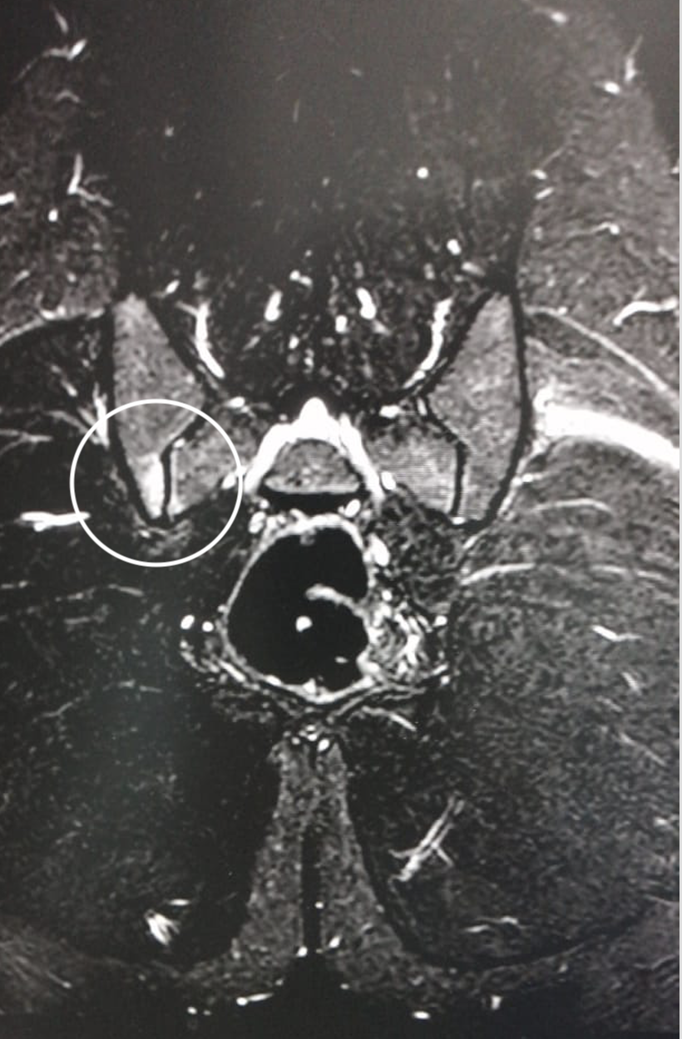
Figure 3. MRI of the sacroiliac joints 07.07.2019. Signs of the sacroiliitis right side.

Therapeutic intervention
From the beginning of the first symptoms therapy was carried out, including refusing training loads, taking NSAIDs (Celecoxib 400 mg / day), local injections of Diprospan into the inflamed joints of the foot (0.5 ml of diprospan + 0.5 ml of lidocaine once 1per week for 2 weeks), immobilization (an orthosis splint for the ankle joint Bauerfeind), cryotherapy (20 minutes 2 times a day), magnetotherapy (permanent magnetic field up to 300 minutes per day).
Further therapy is presented in table 1.

Date | Clinical picture | Physical loading | Blood | Treatment | Dose
Starting therapy 1-2 months (April June) | Pronounced;  BASDAI=5,9 | Rest | ESR - 20  CRP - 20  Iron - 5  Hemoglobin - 110  Ferritin 35 | - Celecoxib  - Sulfasalazine  - Betamethasone intraarticular (ankle and foot joints)  - Immobilization  - Cryotherapy  - Magnetotherapy | 400 mg/day  500-3000 mg/day  once 1per week for 2 weeks  orthosis Bauerfeind  20 minutes 2 times a day  permanent magnetic field up to 300 minutes per day
3-6 months (June September) | Pronounced;  BASDAI=5,2 | Light exercise therapy/  Lack of football specific exercises | ESR - 60  CRP - 50  Iron - 3  Hemoglobin - 105  Ferritin 30 | - Sulfasalazine  - Celecoxib  - Doxycycline  - Cryotherapy  - Magnetotherapy | 2 g/day  400 mg/day  200 mg/day  20 minutes 2 times a day  permanent magnetic field up to 300 minutes per day
6-9 months (October February) | Stable;  BASDAI=4,0 | Individual training in the gym and on the field | ESR - 15  CRP - 11 Iron - 15 Hemoglobin - 118  Ferritin - 38 | - Sulfasalazine  - Ibuprofen  - Secukinumab  - Cryotherapy  - Magnetotherapy | 500 mg/day  400 mg  150 mg subcutaneously 1-4 times/month  20 minutes 2 times a day  permanent magnetic field up to 300 minutes per day
10 months (March) | Pronounced;  BASDAI=5,5  Edema of the bones of the right foot and pubic bones | Exercise therapy | ESR - 60  CRP - 50 Iron - 3  Hemoglobin - 100  Ferritin - 30 | - Secukinumab  - Cryotherapy  - Ultrasound therapy with hydrocortisone  - Magnetotherapy | 150 mg subcutaneously 1 time/month  20 minutes 2 times a day  20 min/day  permanent magnetic field up to 300 minutes per day
11-14 months until now | Stable;  11 months: BASDAI=3,6  12 months:  BASDAI=2,9  13 months:  BASDAI=2,4  14 months:  BASDAI=2,1 | From 14 month - training in the general group and additional strength training for muscles stabilizing the affected joints | ESR - 6  CRP - 0.5 Iron - 17 Hemoglobin - 138  Ferritin - 150 | - Methotrexate  - Golimumab  - Folic acid | 10 mg 1 time/week 2 weeks, 15 mg 1 time/week 2 weeks, 20 mg 1 time/week  50 mg subcutaneously 1 time/month  10 mg 12 hour after Methotrexate
Table 1. The treatment and dynamics of the patient's condition

Over the entire period of treatment, side effects and allergic reactions were not recorded.
After 6 months of therapy, severe clinical symptoms began to decrease and the patient's condition stabilized. However, by the 10th month of therapy, the condition worsened, which led to a change in therapy and an improvement in the clinical picture.
Over the next four months, therapy did not change, and physical activity progressively increased - all this time the condition remained stable. No extraarticular lesions were observed during the entire duration of the clinical manifestation.
The patient returned to regular training activities in August 2019. Held the first match on a professional level 08/19/2019.
Therapy is currently (March 2020): methotrexate 20 mg once a week, folic acid (10 mg) once a week, Simponi 50 mg subcutaneously once a month.
Additionally, the athlete receives: calcium (500 mg per day), vitamin D (5000 units / day, Fosamax 10 mg (1 time per week), additional strength training for muscle stabilizers, massage, physiotherapy (magnetotherapy, electrical stimulation, cryotherapy)
Blood analysis in March 2020: ESR 6, CRP 0.9, iron 17, hemoglobin 148, ferritin 40.
BASDAI index dynamic (Table 1.; Figure 4).
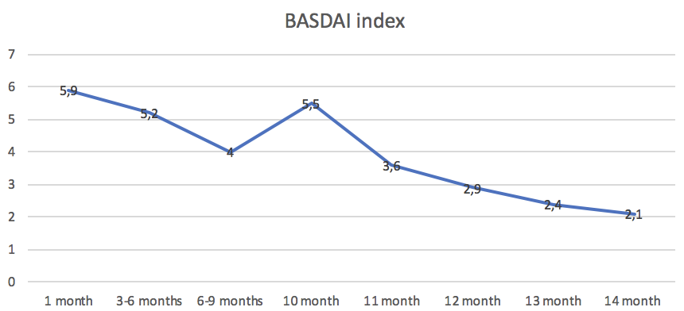
Figure 4. BASDAI index dynamic (high activity of the disease >4).

The most common outcomes for ankylosing spondylitis are a decrease in locomotor activity associated with inflammatory joint damage.
The course of the disease can be different, but most often for several years the joint mobility has been irreversibly reduced and almost always the diagnosis of AS makes sports impossible due to chronic inflammation [11], a decrease in bone mineral density and an increased risk of fractures [7], reduction of core stability and balance [12].
Only one publication describing the case of ankylosing spondylitis in an athlete is the work of Miller et al. which described the case of successful treatment of this disease with a monthly course of indomethacin. However, after the clinical symptoms subsided, the patient was no longer involved in sports. [10]
However, in the situation described in the patient's case, inflammation in the body does not occur even with a maximum load, which is achieved by taking methotrexate and simponi according to the scheme.
Therefore, we believe that the ongoing therapy and the answer to it allows us to count on the continuation of the professional career of a football player.
However, constant monitoring of inflammation markers is necessary for timely correction of therapy.
It should also be noted that the therapy is expensive (about 1500 dollars / month) and requires a high level of qualification from the doctor who carries it out, which is not accessible to everyone.
Another important limiting aspect may be side effects and allergic reactions that may accompany any long-term therapy.

Conclusion
The case described by us is probably the first described case of a patient returning to professional sports with a similar diagnosis. There are cases of returning to sports with rheumatoid arthritis (tennis player Caroline Wozniacki, a professional hockey player from Finland) but they are not disassembled and are not described in the literature.
Further monitoring is needed and the creation of a unified database of athletes with similar diseases to unify treatment protocols for patients with initially very high levels of physical activity.

References:
- Rudwaleit M, van der Heijde D, Landewé R, Listing J, Akkoc N, Brandt J, Braun J, Chou CT, Collantes-Estevez E, Dougados M, Huang F, Gu J, Khan MA, Kirazli Y, Maksymowych WP, Mielants H, Sørensen IJ, Ozgocmen S, Roussou E, Valle-Oñate R, Weber U, Wei J, Sieper J. The development of Assessment of SpondyloArthritis international Society classification criteria for axial spondyloarthritis (part II): validation and final selection. Ann Rheum Dis. 2009 Jun;68(6):777-83. doi: 10.1136/ard.2009.108233. Epub 2009 Mar 17.
- Garcia-Montoya L, Gul H, Emery P. Recent advances in ankylosing spondylitis: understanding the disease and management. F1000Res. 2018 Sep 21;7. pii: F1000 Faculty Rev-1512. Doi: 10.12688/f1000research.14956.1
- Chen B, Li J, He C, Li D, Tong W, Zou Y, Xu W. Role of HLA-B27 in the pathogenesis of ankylosing spondylitis (Review). Mol Med Rep. 2017 Apr;15(4):1943-1951. doi: 10.3892/mmr.2017.6248. Epub 2017 Feb 24.
- Cortes A, Pulit SL, Leo PJ, Pointon JJ, Robinson PC, Weisman MH, Ward M, Gensler LS, Zhou X, Garchon HJ, Chiocchia G, Nossent J, Lie BA, Førre Ø, Tuomilehto J, Laiho K, Bradbury LA, Elewaut D, Burgos-Vargas R, Stebbings S, Appleton L, Farrah C, Lau J, Haroon N, Mulero J, Blanco FJ, Gonzalez-Gay MA, Lopez-Larrea C, Bowness P, Gaffney K, Gaston H, Gladman DD, Rahman P, Maksymowych WP, Crusius JB, van der Horst-Bruinsma IE, Valle-Oñate R, Romero-Sánchez C, Hansen IM, Pimentel-Santos FM, Inman RD, Martin J, Breban M, Wordsworth BP, Reveille JD, Evans DM, de Bakker PI, Brown MA. Major histocompatibility complex associations of ankylosing spondylitis are complex and involve further epistasis with ERAP1. Nat Commun. 2015 May 21;6:7146. doi 10.1038/ncomms8146.
- Stolwijk C, van Onna M, Boonen A, van Tubergen A. Global Prevalence of Spondyloarthritis: A Systematic Review and Meta-Regression Analysis. Arthritis Care Res (Hoboken). 2016 Sep;68(9):1320-31. doi: 10.1002/acr.22831. Epub 2016 Jul 27.
- Gran JT, Husby G, Hordvik M. Prevalence of ankylosing spondylitis in males and females in a young middle-aged population of Tromsø, northern Norway. Ann Rheum Dis. 1985 Jun;44(6):359-67. doi: 10.1136/ard.44.6.359
- Briot K, Roux C. Inflammation, bone loss and fracture risk in spondyloarthritis. RMD Open. 2015 Jul 14;1(1):e000052. doi: 10.1136/rmdopen-2015-000052. eCollection 2015.
- Weber U, Baraliakos X. Imaging in axial spondyloarthritis: Changing concepts and thresholds. Best Pract Res Clin Rheumatol. 2018 Jun;32(3):342-356. doi: 10.1016/j.berh.2018.10.009. Epub 2018 Nov 17.
- Kyoung-Ho Moon, MD, PhD and Young-Tae Kim, MD. Medical Treatment of Ankylosing Spondylitis. Hip Pelvis. 2014 Sep; 26(3): 129–135. Published online 2014 Sep 29. doi: 10.5371/hp.2014.26.3.129 PMCID: PMC4971137 PMID: 27536570
- Miller TL, Cass N, Siegel C. Ankylosing spondylitis in an athlete with chronic sacroiliac joint pain. Orthopedics. 2014. Orthopedics. 2014 Feb;37(2):e207-10. doi: 10.3928/01477447-20140124-27.
- Huang SW, Wang JY, Lin CL, Huang CC, Liou TH, Lin HW. Patients with Axial Spondyloarthritis Are at Risk of Developing Adhesive Capsulitis: Real-World Evidence Database Study in Taiwan. J Clin Med. 2020 Mar 13;9(3). pii: E787. doi: 10.3390/jcm9030787.
- Acar Y, Ilçin N, Gürpinar B, Can G. Core stability and balance in patients with ankylosing spondylitis. Rheumatol Int. 2019 Aug;39(8):1389-1396. doi: 10.1007/s00296-019-04341-5. Epub 2019 Jun 12.

