‘Early-born’ and ‘later-born’ players: how many are there, and who worth more?

Eduard Bezuglov ^{1,2,3,9} Ryland Morgans ^{1,9} Vladimir Khaitin ⁴, Anton Emanov ⁵, Denis Orlov ⁵, Anastasiya Lyubushkina ⁵, Ekaterina Barskova, ¹ Olga Ivanova⁶, Artemii Lazarev ², Zbigniew Waśkiewicz ^{7,8}

¹ Sechenov First Moscow State Medical University (Sechenov University), Moscow, Russian Federation; e.n.bezuglov@gmail.com (EB); em.barskova@gmail.com (EB);
² High Performance Sports Laboratory, Moscow Witte University, Moscow, Russian Federation; e.n.bezuglov@gmail.com (EB); lazarevartemii1@gmail.com (AL);
³ Federal Research and Clinical Center of Sports Medicine and Rehabilitation of Federal Medical Biological Agency, Moscow, Russian Federation; e.n.bezuglov@gmail.com (EB);
⁴ Pavlov First Saint Petersburg State Medical University, St. Petersburg, Russian Federation; khaitinvladimir@gmail.com (VK);
⁵ Smart Recovery Sports Medicine Clinic, Moscow, Russia; 5184436@gmail.com (AE); info@smartrecovery.su (DO); nastya.lyubuskina@mail.ru (AL);
⁶ Faculty of Medicine, Moscow State University, Moscow, Russian Federation; ivanolla17@gmail.com (OI);
⁷ Institute of Sport Science, Jerzy Kukuczka Academy of Physical Education, Katowice, Poland; z.waskiewicz@awf.katowice.pl (ZW)
⁸ Department of Sports Medicine and Medical Rehabilitation, Sechenov University, Moscow, Russian Federation;
⁹ PFC CSKA, Moscow, Russian Federation;
*Corresponding author:

Abstract
Background
Studying the prevalence of RAE depending on the level of competition and position on the field, as well as analyzing the relationship between the player’s birth quarter and market value, are of scientific interest.
Methods
The dates of birth, position on the field and market value of all adult male players included in the final rosters of the top-division teams of 54 European countries, listed on www.transfermarkt.com on August 15th, 2020, were analyzed (18,429 soccer players in total).

Results
Of 18,429 players, 30.9% (5,688) were born in Q1, 25.7% (4,739) in Q2, 23.8% (4,393) in Q3, and 19.6% (3,609) in Q4. The number of soccer players born in Q1 lowers with reducing level of competition.
Transfer costs did not differ significantly between players of various positions born in Q1-Q4, and between ‘early-born’ and ‘later-born’ players.

Conclusions
Relative age effect is currently prevalent in all of the most competitive senior soccer leagues and teams in Europe regardless of the field position.
There is no difference in market value between players of the same position on the field and level of competition born in different quarters. At the same time, the most expensive soccer players in the European championships are precisely the late-born forwards.

Keywords: relative age effect, soccer, market value, talent identification

Introduction
The Relative Age Effect (RAE) is the reduction in the frequency of members born in the last months to a threshold beyond which a new age category is established [1]. One of the earliest works to describe RAE in sports was Barnsley et al., Who reported that about 40% of young ice hockey players in Canada were born in the first quarter of the year [2]. Since then, a large number of studies on RAE in sports have been published. Most likely, RAE is most widespread in groups of young male athletes (age 15-18) performing at a high competitive level in the most popular sports such as soccer, athletics, basketball, etc. [3-7].
In athletes' populations where the end date is January 1, the number of athletes born between January and March may be several times higher than the number of athletes born between October and November [7]. At the same time, athletes born in September, October and November will be overrepresented in groups of athletes (for example, in cricket in Australia) where a different endpoint is used (September 1) [8].
The main negative factor in RAE is the "discrimination" of younger athletes, who are often less physically developed. This is confirmed by several studies conducted among children and adolescents involved in sports.
For example, a study by Romann et al. showed that the difference in performance in a 60-meter sprint between early and late born teens 8-15 years old is 5-10% [19].
Similar data were obtained by Muller et al. among young skiers [20].
In particular, RAE has also been spotted in the top elite soccer and hockey leagues. For example, it has been described among NHL hockey players [9], soccer players participating in UEFA tournaments [10], and in the top European soccer leagues [11].
However, the prevalence of RAE in older athletes is not as high as in younger athletes [12,13]. Some studies have even described the phenomenon of change in RAE in elite leagues, which is characterized by the predominance of late-born players over early-born ones [14,15].
In their article, Fumarco et al. give several explanations for the phenomenon of RAE reversion in elite sports leagues, in particular in the NHL [15]. In this regard, it is not surprising that the change in RAE was associated with higher success rates for young players [15]: they had higher salaries [16, 17], scored more points [18] and had a longer career [14, 17]. Similar mechanisms can be found in elite soccer.
Recently, there has also been a growing interest in analyzing the relationship between a player's date of birth and his market value. Furley et al. found that among the top 100 soccer players, “early born” were more numerous and had a higher average market value [21]. On the other hand, Doyle et al. analyzed the top 1000 professional and UEFA Youth League U19 players and found that the market value of early-born players does not exceed the market value of late-born players. [22]
In this sense, it is interesting to study the different aspects of the prevalence of RAE in European adult soccer, depending on the level of competition and the position on the field, as well as the relationship between the quarter of birth and the market value of the players.

Materials and methods
The materials used in this article are based on the data on the top division squads of 54 European countries downloaded from www.transfermarkt.com. Data were publicly available as of September 10, 2020. This website has not previously been used to study the prevalence of RAE in soccer, however, it has proven to be accurate and reliable. The transfermartkt.com website is the largest database of soccer statistics. Information from it is often used in various scientific studies published by leading experts in prestigious journals [1, 23-25].
For data mining, software was used using the PHP Simple HTML DOM Parser library. All publicly accessible pages have been “analyzed” page by page to obtain information on the player's date of birth, position on the field and market value.
The collected data was organized into a MySQL database, which was then used to design queries to select and interpret the required data. Local ethics committee approval was not required when using open source data.
Overall, the analysis included data on 18,429 soccer players from 731 top division teams playing in 54 European Championships (there are no national championships in the Principality of Liechtenstein).
These 54 countries have been divided into 5 groups based on the level of representation of the country's soccer clubs in the 2018/2019 UEFA Champions Cup [26], as this appears to be the most objective method of classifying European club soccer.
Group 1 included 6 countries that had the maximum or submaximal representation of 7 or 6 clubs in the Champions Cup, respectively (Spain, England, Germany, Italy, France, Russia).
Group 2 included 9 countries, five teams in the Champions Cup (Portugal, Belgium, Ukraine, Turkey, Netherlands, Austria, Czech Republic, Greece, Switzerland).
The third group included 35 countries, 4 teams in each (Denmark, Croatia, Cyprus, Serbia, Scotland, Belarus, Sweden, Norway, Kazakhstan, Poland, Azerbaijan, Israel, Bulgaria, Romania, Slovakia, Slovenia, Hungary, Albania, North Macedonia, Bosnia and Herzegovina, Moldova, Ireland, Finland, Georgia, Malta, Iceland, Wales, Northern Ireland, Montenegro, Estonia, Faroe Islands, Luxembourg, Armenia, Latvia and Lithuania).
The fourth group includes 4 countries with 1-3 teams in the Champions Cup (San Marino, Andorra, Kosovo, Gibraltar).
The top 50 European teams according to the UEFA ranking 2019/2020 [27] were analyzed separately as Group 5.
All players were divided into four groups according to the month of birth:
- Players born in the first quarter of the year (January, February, March) (Q1, early born)
- Players born in the second quarter of the year (April, May, June) (Q2)
- Players born in the third quarter of the year (July, August, September) (Q3)
- Players born in the fourth quarter of the year (October, November, December) (fourth quarter born later).
The effect of relative age was defined as a higher relative sample size in the first quarter compared to other quarters by date of birth.

Statistical analysis
Data were stored in MS Excel. Analysis was performed with SPSS Statistics v.23.0 software (IBM). The chi-square test was used to compare the number of ‘early- born’ and ‘later-born’ players in different groups. The unconditional maximum likelihood estimation and normal approximation (Wald) CI method were used to calculate odds ratios and 95% confidence intervals. The Kruskall-Wallis test was used to compare transfer fees for players born in quarters 1-4 and between groups. For statistically significant differences we also performed a post-hoc pairwise comparisons using the Dunn test with Holm adjustment. Results were considered statistically significant at p < 0.05.

Results
18,429 players compete in 731 top divisions teams of 54 European countries (groups 1-4).
Of these, 30.9% (5,688) were born in Q1, 25.7% (4,739) in Q2, 23.8% (4,393) in Q3 and 19.6% (3,609) in Q4 (Figure 1).
Figure 1. Distribution of players in all European championships by the quarter of birth

The distribution of players by quarter of birth in different groups is represented in Figure 2.
Figure 2 Distribution of players by quarter of birth in groups 1-5.

Among all players 2,075 (11.3%) were goalkeepers, 5,884 (31.9%) were defenders, 7,826 (42.5%) were midfielders, and 2,644 (14.3%) were forwards. RAE was observed in every analyzed group in all positions. Analysis of the dates of birth of players playing in different positions shows that for each position there is a majority of early-born athletes. The strongest RAE was observed in defenders, where 31.3% had been born in Q1 and 19% had been born in Q4. The weakest RAE was observed in the forwards, where 29.5% (781 player) had been born in Q1 and 20.4% (539 people) – in Q4 (Figure 3).

Figure 3. RAE by field position

The mean transfer fees of players in the top divisions of the European championships were 2,013,435 euros. The mean transfer fees by field position were as follows: goalkeepers – 1,165,374 €; defenders – 1,833,209 €; midfielders – 2,275,705 €; forwards – 2,301,902 €.
The mean transfer fees were highest among players born in the fourth quarter (€ 2,200,056) and lowest among players born in the third quarter (€ 1,815,839). The mean transfer fees for players born in the first quarter was € 1,991,380, and € 2,081,436 in the second quarter. Among goalkeepers and defenders, the players with the highest market value were born in the second quarter, and among midfielders and forwards in the fourth. In the most competitive groups (Groups 1, 2 and 5), the highest mean transfer fees were observed for players born in the fourth quarter (Figure 4).

Figure 4. The association between player’s quarter of birth and market value.

Forwards and midfielders had the highest transfer fees in all groups (Figure 5)
Figure 5. Relationship between the player’s field position and transfer fee

Group 1
Group 1 was composed of 114 teams with 3,098 players total.
Of these, 33.3% (1,031) were born in Q1, 25.4% (787) in Q2, 22.2% (687) in Q3 and 19.1% (593) in Q4.
346 of the players were goalkeepers, 1,040 were defenders, 1,286 were midfielders, and 426 were forwards.
In group 1, players born in Q1 (‘early-born’) were most numerous at defender and midfielder positions (34% and 34.2%, respectively). Players born in Q4 (‘later-born’) were most numerous at goalkeeper and forward positions (20.8% and 20.7%, respectively).
The mean transfer fee of players was 8,389,870 €.

Group 2
Group 2 was composed of 143 teams with 3,645 players total.
Of these, 32.3% (1,177) were born in Q1, 26.2% (954) in Q2, 23.3% (848) in Q3 and 18.3% (666) in Q4.
417 of the players were goalkeepers, 1,139 were defenders, 1,582 were midfielders, and 507 were forwards.
In group 2, players born in Q1 (‘early-born’) were most numerous at goalkeeper and defender positions (34.3% and 33%, respectively).
Players born in Q4 (‘later-born’) were most numerous at defender and midfielder positions (18.9% each).
The mean transfer fee in group 2 was 1,253,241 €.
Midfielders and forwards born in Q4 had the highest market values: 1,453,571 and 1,709,226 €, respectively.

Group 3
Group 3 was composed of 429 teams with 10,612 players total.
Of these, 30% (3,184) were born in Q1, 25.7% (2 723) in Q2, 24.5% (2 602) in Q3 and 19.8% (2 103) in Q4.
1,192 of the players were goalkeepers, 3,365 were defenders, 4,509 were midfielders, and 1,546 were forwards.
Approximately 30% of the players in each field position were born in Q1 ('early born'). Players born in Q4 (‘later-born’) were most numerous at forward positions.
The mean transfer fee in group 3 was 288,037 €.
Midfielders born in Q2 and forwards born in Q3 had the highest market values of 334,830 and 330,387 €, respectively.

Group 4
Group 4 was composed of 45 teams with 1,074 players total.
Of these, 27.6% (296) were born in Q1, 25.6% (275) in Q2, 23.8% (256) in Q3 and 23% (247) in Q4.
120 of the players were goalkeepers, 340 were defenders, 449 were midfielders, and 165 were forwards.
Players born in Q1 (‘early-born’) were most numerous at goalkeeper and defender positions (30% and 29.7%, respectively). Players born in Q4 (‘later-born’) were most numerous at goalkeeper and forward positions (25.8% and 25.5%, respectively).
In this group, RAE was the weakest.
The mean transfer fee in group 4 was 77,062 €.
Defenders born in Q4 and forwards born in Q1 had the highest market values of 114,423 and 95,455 €, respectively.

Group 5
Group 5 was composed of 50 teams with 1460 players total.
Of these, 33.1% (483) were born in Q1, 26.2% (382) in Q2, 22.4% (327) in Q3 and 18.4% (268) in Q4.
155 of the players were goalkeepers, 494 were defenders, 623 were midfielders, and 188 were forwards.
Players born in Q1 (‘early-born’) were most numerous at goalkeeper and defender positions (34.2% and 31.7%, respectively).
Players born in Q4 (‘later-born’) were most numerous at goalkeeper position (21.9%).
The mean transfer fee in group 5 was 12,963,191 €.

Comparison between groups
When comparing the dates of birth of players from different groups of countries, there is a correlation between the level of competition and the number of players born later. As the productivity of teams grows, the number of players born in the fourth quarter in their lineup decreases.
Table 1 shows the difference between the number of “born later” players in different groups. In all cases where the difference was statistically significant (p <0.05), there were more “born later” players in the, less elite groups.

Table 1. Differences between the numbers of ‘later-born’ players in various groups (p values) — Chi-square.
ALL PLAYERS | Group 1 | Group 2 | Group 3 | Group 4 | Group 5
Group 1 |  | 0.36 | 0.40 | p = 0.007  OR = 1.26  95% CI 1.07-1.49 | 0.53
Group 2 |  |  | p = 0.038  OR = 1.10  95% CI 1.00-1.22 | p = 0.001  OR = 1.34  95% CI 1.13-1.58 | 0.94
Group 3 |  |  |  | p = 0.013  OR = 1.21  95% CI 1.04-1.40 | 0.18
Group 4 |  |  |  |  | p = 0.005  OR = 0.75  95% CI 0.62-0.91
Group 5

Table 2 shows the differences in the number of "early born" players in different groups. In all cases where the difference was statistically significant (p <0.05), there were more “early-born” players in the more elite groups.
Table 2. Differences between the numbers of ‘early-born’ players in various groups (p values) — Chi-square.
ALL PLAYERS | Group 1 | Group 2 | Group 3 | Group 4 | Group 5
Group 1 |  | p = 0.39 | p = 0.001  OR = 0.86  95% CI 0.79-0.94 | p = 0.001  OR = 0.76  95% CI 0.65-0.89 | p = 0.90
Group 2 |  |  | p = 0.01  OR = 0.90  95% CI 0.83-0.98 | p = 0.003  OR = 0.79  95% CI 0.69-0.93 | p = 0.59
Group 3 |  |  |  | p = 0.095 | p = 0.017  OR = 1.15  95% CI 1.03-1.30
Group 4 |  |  |  |  | p = 0.003  OR = 1.30  95% CI 1.09-1.54
Group 5

Group 4, which included teams from the least competitive European Championships, was the only group in which the RAE hardly existed.
Transfer fees did not differ significantly between players born in quarters 1-4, and between players born early and late (p> 0.05) (Table 3).
In all groups except group 4, the proportion of players born in the first quarter was 30% or more (Table 4).
The highest share of players born in the fourth quarter (23%) was observed in group 4.
In all other groups, their total share did not exceed 20% (Table 5).

Table 3. Differences between transfer costs across Q1-4 — Kruskall-Wallis test
 | Statistics | Q1 | Q2 | Q3 | Q4 | p-value
All players
 | Mean | 3 631 315.6 | 4 576 169.4 | 4 671 688.6 | 5 243 942.0 | 0.95
 | Std. deviation | 4 955 537.26 | 6 011 980.19 | 5 794 754.18 | 6 620 312.58
 | Min. | 77 462 | 73 256 | 73 913 | 84 404
 | Max. | 11 867 217 | 13 927 083 | 12 118 210 | 14 589 015
Goalkeepers | Mean | 2 547 860.6 | 3 364 190.8 | 1 893 253.8 | 2 522 341.8 | 0.95
 | Std. deviation | 3 048 045.77 | 4 305 097.70 | 2 075 306.93 | 3 258 930.76
 | Min. | 70 455 | 68 750 | 90 625 | 42 188
 | Max. | 6 622 500 | 10 025 714 | 4 820 833 | 7 375 000
Defenders | Mean | 3 755 068.2 | 4 542 361.0 | 3 672 883.2 | 4 458 000.2 | 0.89
 | Std. deviation | 4 713 027.24 | 5 896 672.66 | 4 516 304.24 | 5 600 505.28
 | Min. | 61 000 | 82 558 | 77 717 | 114 423
 | Max. | 10 504 360 | 13 438 478 | 9 904 783 | 12 732 229
Midfielders | Mean | 5 122 658.6 | 5 352 984.0 | 5 119 504.6 | 5 505 792.0 | 0.98
 | Std. deviation | 6 501 088.77 | 6 763 524.54 | 6 475 764.89 | 6 873 286.38
 | Min. | 87 755 | 58 654 | 60 119 | 93 229
 | Max. | 14 698 684 | 14 825 857 | 14 405 303 | 14 922 588
Forwards | Mean | 4 199 277.0 | 5 382 842.8 | 5 294 129.4 | 8 145 623.2
 | Std. deviation | 4 972 403.44 | 6 742 400.46 | 6 980 970.51 | 11 144 686.57 | 0.99
 | Min. | 95 455 | 92 045 | 88 158 | 56 579
 | Max. | 11 142 105 | 14 681 383 | 15 768 617 | 25 539 394
Table 4. Distribution of ‘early-born’ players in various groups
 | Groups
 | 1 | 2 | 3 | 4 | 5
‘early-born’ (Q1) | 1031 (33.28%) | 1177 (32.29%) | 3184 (30.00%) | 296 (27.56%) | 483 (33.08%)
Q2-Q4 | 2067 (66.72%) | 2468 (67.71%) | 7428 (70.00%) | 778 (72.44%) | 977 (66.92%)
All | 3098 | 3645 | 10612 | 1074 | 1460

Table 5. Distribution of ‘later-born’ players in various groups
 | Groups
 | 1 | 2 | 3 | 4 | 5
‘later-born’ (Q4) | 593 (19.14%) | 666 (18.27%) | 2103 (19.82%) | 247 (23.00%) | 268 (18.36%)
Q1-Q3 | 2505 (80.86%) | 2979 (81.73%) | 8509 (80.18%) | 827 (77.00%) | 1192 (81.64%)
All | 3098 | 3645 | 10612 | 1074 | 1460

Mean transfer fees differed significantly across various groups for all players, goalkeepers, defenders, midfielders and forwards (p = 0.001). The highest price of player was observed in Group 5, while the lowest was observed in Group 4. (Table 6).
Table 6. Differences between transfer costs across groups — Kruskall-Wallis test
 | Statistics | Group 1 | Group 2 | Group 3 | Group 4 | Group 5 |  | p-value
All players | Mean | 7 907 944.0 | 1 254 712.8 | 288 597.8 | 77 258.8 | 13 125 381.2 |  | 0.001
 | SD | 2 475 311.66 | 99 332.91 | 8 002.92 | 5 109.21 | 1 339 442.75
 | Min. | 4 646 563 | 1 118 270 | 278 120 | 73 256 | 11 867 217
 | Max. | 9 901 718 | 1 354 255 | 297 507 | 84 404 | 14 589 015
Goalkeepers | Mean | 4 510 579.5 | 925 038.5 | 194 924.5 | 68 004.5 | 7 211 011.8 |  | 0.001
 | SD | 927 264.15 | 275 244.89 | 24 963.26 | 19 872.42 | 2 160 921.21
 | Min. | 3 250 000 | 577 574 | 158 829 | 42 188 | 4 820 833
 | Max. | 5 370 989 | 1 145 982 | 213 500 | 90 625 | 10 025 714
Defenders | Mean | 7 383 739.2 | 1 139 765.0 | 282 999.5 | 83 924.5 | 11 644 962.5 |  | 0.001
 | SD | 462 463.94 | 134 929.60 | 23 429.07 | 22 331.53 | 1 705 681.20
 | Min. | 6 920 415 | 1 021 781 | 267 785 | 61 000 | 9 904 783
 | Max. | 7 800 785 | 1 325 000 | 317 564 | 114 423 | 13 438 478
Midfielders | Mean | 9 870 444.0 | 1 404 968.5 | 312 714.2 | 74 939,2 | 14 713 108.0 |  | 0.001
 | SD | 765 074.38 | 80 863.72 | 21 541.47 | 18 107.16 | 224 756.30
 | Min. | 9 049 884 | 1 318 496 | 285 761 | 58 654 | 14 405 303
 | Max. | 10 753 517 | 1 491 209 | 334 830 | 93 229 | 14 922 588
Forwards | Mean | 10 146 349.8 | 1 460 760.2 | 304 296.5 | 83 059.2 | 16 782 874.8 |  | 0.001
 | SD | 2 296 107.09 | 307 373.34 | 33 929.39 | 17 903.44 | 6 162 788.85
 | Min. | 7 743 388 | 1 053 125 | 257 801 | 56 579 | 11 142 105
 | Max. | 13 165 116 | 1 709 226 | 330 387 | 95 455 | 25 539 394

We also performed post hoc pairwise comparisons using the Dunn test with Holm adjustment which showed significant differences in transfer fees between groups 1-4, 4-5 and 3-5 (Table 7).
Table 7. Differences between transfer fees between groups (p values) - Dunn test with Holm adjustment.
ALL PLAYERS | Group 1 | Group 2 | Group 3 | Group 4 | Group 5
Group 1 |  | p = 1 | p = 0.39 | p = 0.037 | p = 0.34
Group 2 |  |  | p = 1 | p = 0.33 | p = 0.28
Group 3 |  |  |  | p = 0.68 | p = 0.033
Group 4 |  |  |  |  | p = 0.0013
GOALKEEPERS | Group 1 | Group 2 | Group 3 | Group 4 | Group 5
Group 1 |  | p = 1 | p = 0.29 | p = 0.025 | p = 0.47
Group 2 |  |  | p = 1 | p = 0.33 | p = 0.36
Group 3 |  |  |  | p = 0.68 | p = 0.048
Group 4 |  |  |  |  | p = 0.0021
DEFENDERS | Group 1 | Group 2 | Group 3 | Group 4 | Group 5
Group 1 |  | p = 1 | p = 0.39 | p = 0.037 | p = 0.34
Group 2 |  |  | p = 1 | p = 0.33 | p = 0.27
Group 3 |  |  |  | p = 0.68 | p = 0.033
Group 4 |  |  |  |  | p = 0.0013
MIDFIELDERS | Group 1 | Group 2 | Group 3 | Group 4 | Group 5
Group 1 |  | p = 1 | p = 0.39 | p = 0.037 | p = 0.34
Group 2 |  |  | p = 1 | p = 0.33 | p = 0.28
Group 3 |  |  |  | p = 0.68 | p = 0.033
Group 4 |  |  |  |  | p = 0.013
FORWARDS | Group 1 | Group 2 | Group 3 | Group 4 | Group 5
Group 1 |  | p = 1 | p = 0.34 | p = 0.031 | p = 0.40
Group 2 |  |  | p = 1 | p = 0.33 | p = 0.32
Group 3 |  |  |  | p = 0.68 | p = 0.040
Group 4 |  |  |  |  | p = 0.0017

Discussion
RAE is described in many groups of soccer players of all levels and has different distribution patterns depending on a number of factors, including competitive level, age, playing position, and even nationality [33, 34].
According to a number of studies in soccer, RAE is most pronounced among high-level young male soccer players (under 18), and it can significantly influence the careers of young footballers [37-39].
For example, in German soccer, which is one of the most competitive in the world, early-born soccer players have a greater probability of becoming a professional player [35]. And in French soccer, which is also one of the leading in the world, late-born soccer players are more likely to drop out of training than early-born players [36].
The widespread and strengthening of RAE in elite European youth and adult soccer over the past decades may be due to the increase in the level of popularity of soccer and, accordingly, the increase in the level of competition, as well as the mechanisms and timing of the initial selection. Considering the fact that in recent years the primary selection in the leading European soccer academies takes place before the age of 10 years, it becomes obvious that a difference of even a few months can provide a significant advantage in terms of exercise. Thus, in a study by Gil et al., also revealed statistically significant differences in anthropometry and physical performance among older and younger prepubertal football players with an average age of 9.75 ± 0.30 years [40].
In this situation, only the “late-born” children with a higher status of biological maturity are likely to have the opportunity to compete with the “early-born” ones. This is supported by the study by Müller et al., they analyzed the prevalence of RAE and the degree of biological maturity among 222 male participants in the UEFA European Under-9 Football Championship. The results from the study showed that the primary selection process in children's international football appears to be related to biological maturity status and relative age, and late-born children seem to be more likely to be selected for highly competitive football organizations if they have a higher biological level of maturity [41].
Already at the very early stages of selection in the most competitive football organizations, a redistribution of early-born children appears, and underrepresented late-born children have a chance to pass selection and compete under the condition of a more pronounced biological maturity. In this situation, under the existing selection system, late-maturing post-born children may be subjected to a kind of discrimination, and during this period of time, the first and key stage of dropping out of no less talented, but temporarily more physically and psychologically weak children occurs. The second stage of elite youth soccer elimination occurs already during the growth spurt (12-14 years) when the elimination of athletes in many highly competitive sports organizations in sports can occur under the influence of different rates of biological maturation [29, 42, 43].
In this case, young soccer players with normal and delayed biological maturation are discriminated against, and the advantage, apparently, is given to early maturing children, regardless of the date of birth. This statement is well illustrated by the data of Malina et al. They analyzed the degree of biological maturation of young elite Portuguese soccer players of the Portuguese academies in the age groups 11 years old (before puberty), 13-14 years old and 16-17 years old. In these age groups, the number of soccer players with different degrees of maturation varied significantly. According to the data obtained, at the age of 11-12 years, the proportion of boys with late and early maturation was the same and amounted to 21%, among players aged 13-14 years, the percentage of late and early maturing boys was 7% and 38%, respectively, and among players at the age of 15-16 years, the percentage of late and early maturing boys was 2% and 65%, respectively. The results of this study show that late maturing boys are systematically excluded from elite youth soccer, and as chronological age and sport specialization increase, preference is given to “on time” and early maturing boys [44].
Considering the above facts, we can confidently say that late-born children are not less talented, but become victims of bias at different stages of selection in highly competitive sports organizations in sports where the most important physical qualities are strength and speed.
In this regard, it becomes understandable why the cost of late-born football players can be lower in adolescence and be compared with early-born in adulthood, when the degree of biological maturation ceases to play any role.
This study is one of the largest RAE studies in European soccer. Its distinguishing features are a relatively large sample (18,429 players) and a comparison of the prevalence of RAE in groups of different competitiveness, consisting of teams from different countries. It would be interesting to compare the results with those of other studies.
The study found that RAE prevailed in European adult soccer at almost all competition levels and for every position on the pitch. The number of players born in Q1 decreases as the level of competition decreases; the highest percentage of these players is observed in clubs that are among the top 50 players in UEFA or compete in the most prestigious European championships. Least pronounced RAE in teams that participate in the least competitive championships.
Similar results were obtained Salinero et al., they analyzed the quarter of birth of players from the top five European leagues (England, Italy, Germany, France and Spain, n = 2763). They found that players born in the first quarter were always overrepresented compared to players born in the other three quarters [28].
This widespread adoption of RAE in major leagues may be due to the high overrepresentation of early-born soccer players in the highly competitive soccer academies, which are likely to graduate from senior league teams, in adolescence. That is, there are significantly fewer late-born soccer players in late youth soccer.
The absence of RAE in the least competitive championships (group 4) may be due to the low level of competition in these countries in the primary selection and the large number of “local” soccer players in adult teams.
At the same time, although transfer values in the most competitive groups (Groups 1, 2, and 5) were highest for players born in the fourth quarter, the Kruskall-Wallis test showed that transfer costs did not differ significantly between players in different positions. born in Q1-Q4, as well as between "early born" and "later born" players.
The similar cost of early and late-born football players in adulthood confirms, at a minimum, their comparable compliance with the highest standards of modern adult soccer and dictates the need to take measures to reduce the severity of RAE in childhood and youth soccer.
At the same time, it must be admitted that despite a large number of studies showing the negative impact of this effect on the development programs of soccer players in many countries, its severity in European countries with a high level of football development from 2001 to 2011 did not decrease and is currently until 2018. There are no countries in Europe protected from it [22, 45].
The study by Salinero et al. (2013) carried out among adult soccer players also revealed the redistribution of early-born soccer players in all the most competitive groups of championships, and it persisted even when the players were divided according to playing positions. In most groups, there were more “early-borns” among goalkeepers and defenders than in other positions. This can be explained by certain requirements for the anthropometric data of soccer players performing in these positions (high growth and large muscle mass), which can lead to elimination or transfer to other positions at various stages of selection of smaller and larger players in a specific period of time. The RAE mattered most to midfielders and defenders [28].
In our study, this group of championships corresponds to group 1 (which, in addition to the countries listed above, included Russia). Like Salinero et al, we found that the percentage of players born in the first quarter (33.3%) was higher than among players born in other quarters of the year, with the most being in defensive and midfielder positions (34, 0% and 34.2%, respectively) [28].
The prevalence of RAE among elite adult midfielders can be associated with both a high level of competition and the requirements of modern soccer, in which midfielders are required to perform a large amount of physical activity at high speed and endurance, which can also depend on the degree of biological maturation [46].
Although there was no difference in intragroup transfer fees between early and late born, the most expensive soccer players were Q4 strikers, which is consistent with Romann et al. in older age groups.
In the study by Romann et al. based on data from transfermarkt.com, the prevalence of RAE was studied among 2,000 of the most expensive soccer players in the 19-23 age groups. Among them, in all age categories, the prevalence of soccer players born in the first quarter (Q1) was also revealed. However, this tendency ceased to exist when the division into game positions. An important result of this study was the change in the transfer value of “early” and “late-born” soccer players with increasing of the age. So, in the age group of 19 years old, the most expensive soccer players were players of the first quarter, and the players aged 21-23 years old were soccer players born in the fourth quarter (Q4) [47].
At the same time, in the study by Doyle et al. no data has been received indicating the different values of the most successful young soccer players. Authors investigated the relationship between a player's market value and date of birth using data on the top 1,000 professionals and UEFA Youth League U19 players. They found no difference between the market value of players born at an early age and those born later [22]. Like Doyle et al., We were unable to find any difference in market value between players born in different quarters of the year within their respective country group. This trend continues in all groups, regardless of the level of competition. Interestingly, despite the lack of statistically significant results, the total value of players born in the fourth quarter exceeded the total value of players born in other quarters of the year.
In the study by Fumarco et al. reported possible reasons for the greater success of late-born athletes at the adult elite level in the NHL [15]. The first explanation is based on psychological stability: later-born outsiders become more psychologically stable and motivated, competing with the "older" players. This is the so-called 'underdog' hypothesis, in which relatively younger players are believed to benefit from more competitive play with their older counterparts [14, 15].
However, given the data on the influence of the degree of biological maturation on the possibility of getting into highly competitive sports organizations and preserving them in them, this theory, at least in relation to children and youth elite soccer players, should be considered with caution [20, 41, 44].
The second explanation is biological: it assumes that the selected “later born” players are more talented, which allows them to compete with the larger “older” players [16].
In our opinion, it is the talent of athletes (which does not depend on the date of birth) that allows them to compete with more physically and psychologically developed peers. In this regard, the main tasks of coaches and scientists should be not only the development and implementation into practice of measures to reduce the discriminatory influence of RAE and the degree of biological maturation on the screening of less mature and late-born soccer players, but also the development of physiological and psychological standards, considering the chronological and biological age, allowing with a high degree of probability to identify sports talent.
The obvious disadvantages of the study include an imperfect way of collecting information. However, this method has been used in previous studies [31], and Transfermarkt has also been shown to provide a reliable estimate of the market value of players. [32].
In the future studies it will be interesting to study the influence of such a factor as player injury on the market value and injury sustained.

Conclusions
The relative age effect is currently prevalent in all of the most competitive senior soccer leagues and teams in Europe regardless of the position on the field.
There is no difference in market value between players of the same position on the field and level of competition born in different quarters. At the same time, the most expensive football players in the European championships are forwards born in the fourth quarter.
These data may indicate that the underrepresentation of “late” soccer players among players of different ages is associated not with their lower talent, but with other factors, most likely based on physiological characteristics.
Acknowledgments: n/a
Disclosure of interest: Authors declare no conflict of interest.

References
- Perez-Gonzalez B, Fernandez-Luna A, Castillo D, et al. Are European Soccer Players Worth More If They Are Born Early in the Year? Relative Age Effect on Player Market Value. International journal of environmental research and public health 2020;17:3301. doi:10.3390/ijerph17093301
- Barnsley RH, Thompson AH, Barnsley PE. Hockey success and birthdate: The RAE. Canadian Association for Health. Phys Educ Recreat J 1985;51:23–8.
- Musch J, Grondin S. Unequal Competition as an Impediment to Personal Development: A Review of the Relative Age Effect in Sport. Developmental Review 2001;21:147–67. doi:https://doi.org/10.1006/drev.2000.0516
- Mujika I, Vaeyens R, Matthys SPJ, et al. The relative age effect in a professional football club setting. Journal of sports sciences 2009;27:1153–8. doi:10.1080/02640410903220328
- Williams JH. Relative age effect in youth soccer: analysis of the FIFA U17 World Cup competition. Scandinavian journal of medicine & science in sports 2010;20:502–8. doi:10.1111/j.1600-0838.2009.00961.x
- Brustio PR, Kearney PE, Lupo C, et al. Relative Age Influences Performance of World-Class Track and Field Athletes Even in the Adulthood. Frontiers in psychology 2019;10:1395. doi:10.3389/fpsyg.2019.01395
- Cobley S, Baker J, Wattie N, et al. Annual age-grouping and athlete development: a meta-analytical review of relative age effects in sport. Sports medicine (Auckland, NZ) 2009;39:235–56. doi:10.2165/00007256-200939030-00005
- Connor JD, Renshaw I, Doma K. Moderating factors influence the relative age effect in Ausralian cricket. Peer J 2019: e6857. doi:10.7717/peerj.6867
- Parent-Harvey CI, Desjardins C, Harvey EJ. Factors affecting the relative age effect in NHL athletes. Canadian journal of surgery Journal canadien de chirurgie 2014;57:157–61. doi:10.1503/cjs.008913
- González-Víllora S, Pastor-Vicedo JC, Cordente D. Relative Age Effect in UEFA Championship Soccer Players. Journal of human kinetics 2015;47:237–48. doi:10.1515/hukin-2015-0079
- Yagüe JM, de la Rubia A, Sánchez-Molina J, et al. The Relative Age Effect in the 10 Best Leagues of Male Professional Football of the Union of European Football Associations (UEFA). Journal of sports science & medicine 2018;17:409–16.
- Bezuglov EN, Nikolaidis PT, Khaitin V, et al. Prevalence of Relative Age Effect in Russian Soccer: The Role of Chronological Age and Performance. International journal of environmental research and public health 2019;16. doi:10.3390/ijerph16214055
- Bezuglov E, Shvets E, Lyubushkina A, et al. Relative Age Effect in Russian Elite Hockey. Journal of strength and conditioning research 2020;34:2522–7. doi:10.1519/JSC.0000000000003687
- Gibbs B, Jarvis J, Dufur M. The Rise of the Underdog? The Relative Age Effect Reversal Among Canadian-born NHL Hockey Players: A Reply to Nolan and Howell. International Review for the Sociology of Sport 2012;47:644–9. doi:10.1177/1012690211414343
- Fumarco L, Gibbs BG, Jarvis JA, et al. The relative age effect reversal among the National Hockey League elite. PLOS ONE 2017;12:e0182827.https://doi.org/10.1371/journal.pone.0182827
- Ashworth J, Heyndels B. Selection bias and peer effects in team sports: The effect of age grouping on earnings of German soccer players. Journal of sports Economics 2007;8:355–77.
- Deaner RO, Lowen A, Cobley S. Born at the wrong time: selection bias in the NHL draft. PloS one 2013;8:e57753. doi:10.1371/journal.pone.0057753
- Bryson A, Gomez R, Zhang T. All-star or benchwarmer? Relative age, cohort size and career success in the NHL. In: Breaking the Ice. Springer 2017. 57–91.
- Romann M, Cobley S. Relative Age Effects in Athletic Sprinting and Corrective Adjustments as a Wolution for Their Removal. PLoS ONE 10(4): e0122988.
- Müller L, Hildebrandt C, Raschner C. The relative age effect and the influence on performance in youth alpine ski racing. J Sports Sci Med. 2015 Mar 1;14(1):16-22.
- Furley P, Memmert D, Weigelt M. “How Much is that Player in the Window? The One with the Early Birthday?” Relative Age Influences the Value of the Best Soccer Players, but Not the Best Businesspeople. Frontiers in psychology 2016;7:84. doi:10.3389/fpsyg.2016.00084
- Doyle JR, Bottomley PA. Relative age effect in elite soccer: More early-born players, but no better valued, and no paragon clubs or countries. PloS one 2018;13:e0192209. doi:10.1371/journal.pone.0192209
- Niederer D, Engeroff T, Wilke J, Vogt L, Banzer W. Return to play, performance, and career duration after anterior cruciate ligament rupture: A case-control study in the five biggest football nations in Europe. Scand J Med Sci Sports. 2018;28(10):2226-2233. doi: 10.1111/sms.13245
- Grassi A, Macchiarola L, Filippini M, Lucidi GA, Della Villa F, Zaffagnini S. Epidemiology of Anterior Cruciate Ligament Injury in Italian First Division Soccer Players. Sports Health. 2020 May/Jun;12(3):279-288. doi: 10.1177/1941738119885642
- Grassi A, Caravelli S, Fuiano M, D'Hooghe P, Filippini M, Della Villa F, Mosca M, Zaffagnini S. Epidemiology of Achilles Tendon Rupture in Italian First Division Football (Soccer) Players and Their Performance After Return to Play. Clin J Sport Med. 2021 Feb 1
- UEFA. Country coefficients. https://www.uefa.com/memberassociations/uefarankings/country/#/yr/2019 (accessed 15 Aug 2020).
- UEFA. Club coefficients. https://www.uefa.com/memberassociations/uefarankings/club/#/yr/2020 (accessed 15 Aug 2020).
- Salinero JJ, Pérez B, Burillo P, et al. Relative age effect in european professional football. Analysis by position. Journal of Human Sport and Exercise 2013;8:966–73.
- Malina RM, Cumming SP, Rogol AD, et al. Bio-Banding in Youth Sports: Background, Concept, and Application. Sports medicine (Auckland, NZ) 2019;49:1671–85. doi:10.1007/s40279-019-01166-x
- Cumming SP, Brown DJ, Mitchell S, et al. Premier League academy soccer players’ experiences of competing in a tournament bio-banded for biological maturation. Journal of sports sciences 2018;36:757–65. doi:10.1080/02640414.2017.1340656
- Peeters T. Testing the Wisdom of Crowds in the field: Transfermarkt valuations and international soccer results. International Journal of Forecasting 2018;34:17–29.
- Herm S, Callsen-Bracker H-M, Kreis H. When the crowd evaluates soccer players’ market values: Accuracy and evaluation attributes of an online community. Sport Management Review 2014;17:484–92.
- Hurley E, Comstock BA, Haile L, Beyer KS. Relative Age Effect in Collegiate Soccer: Influence of Nationality, Playing Position, and Class. J Strength Cond Res 2019;33(12):3295-3301
- Lupo C, Boccia G, Ungureanu AN, Frati R, Marocco R, Brustio PR. The Beginning of Senior Career in Team Sport Is Affected by Relative Age Effect. Front Psychol 2019;26;10:1465.
- Cobley SP, Schorer J, Baker J. Relative age effects in professional German soccer: a historical analysis. J Sports Sci 2008;26(14):1531-8.
- Delorme N, Boiche J, Raspaud M. Relative age and dropout in French male soccer. J Sports Sci 2010;28(7):717-22.
- Romann M, Fuchslocher J. Relative age effects in Swiss junior soccer and their relationship with playing position. Eur J Sport Sci 2013;13(4):356-63.
- Doncaster G, Medina D, Drobnic F, Gómez-Díaz AJ, Unnithan V. Appreciating Factors Beyond the Physical in Talent Identification and Development: Insights From the FC Barcelona Sporting Model. Front Sports Act Living 2020; 31;2:91.
- Práxedes A, Moreno A, García-González L, Pizarro D, Del Villar F. The Relative Age Effect on Soccer Players in Formative Stages with Different Sport Expertise Levels. J Hum Kinet 2017;28;60:167-173.
- Gil SM, Badiola A, Bidaurrazaga-Letona I, Zabala-Lili J, Gravina L, Santos-Concejero J, Lekue JA, Granados C. Relationship between the relative age effect and anthropometry, maturity and performance in young soccer players. J Sports Sci 2014;32(5):479-86.
- Müller L, Gehmaier J, Gonaus C, Raschner C, Müller E. Maturity Status Strongly Influences the Relative Age Effect in International Elite Under-9 Soccer. J Sports Sci Med 2018;14;17(2):216-222.
- Malina RM, Rogol AD, Cumming SP, Coelho e Silva MJ, Figueiredo AJ. Biological maturation of youth athletes: assessment and implications. Br J Sports Med 2015;49(13):852-9.
- Malina RM, Figueiredo AJ, Coelho-E-Silva MJ. Body Size of Male Youth Soccer Players: 1978-2015. Sports Med 2017;47(10):1983-1992.
- Malina RM, Peña Reyes ME, Eisenmann JC, Horta L, Rodrigues J, Miller R. Height, mass and skeletal maturity of elite Portuguese soccer players aged 11-16 years. J Sports Sci 2000;18(9):685-93.
- Helsen WF, Baker J, Michiels S, Schorer J, Van Winckel J, Williams AM. The relative age effect in European professional soccer: did ten years of research make any difference? J Sports Sci 2012;30(15):1665-71.
- Di Salvo V, Gregson W, Atkinson G, Tordoff P, Drust B. Analysis of high intensity activity in Premier League soccer. Int J Sports Med 2009;30(3):205-12.
- Romann, M.; Javet, M.; Cobley, S.; Born, D.-P. How Relative Age Effects Associate with Football Players’ Market Values: Indicators of Losing Talent and Wasting Money. Sports 2021; 9 :99. doi: 10.3390/sports9070099

Figures legends

Figure 1. Distribution of players in all European championships by the quarter of birth
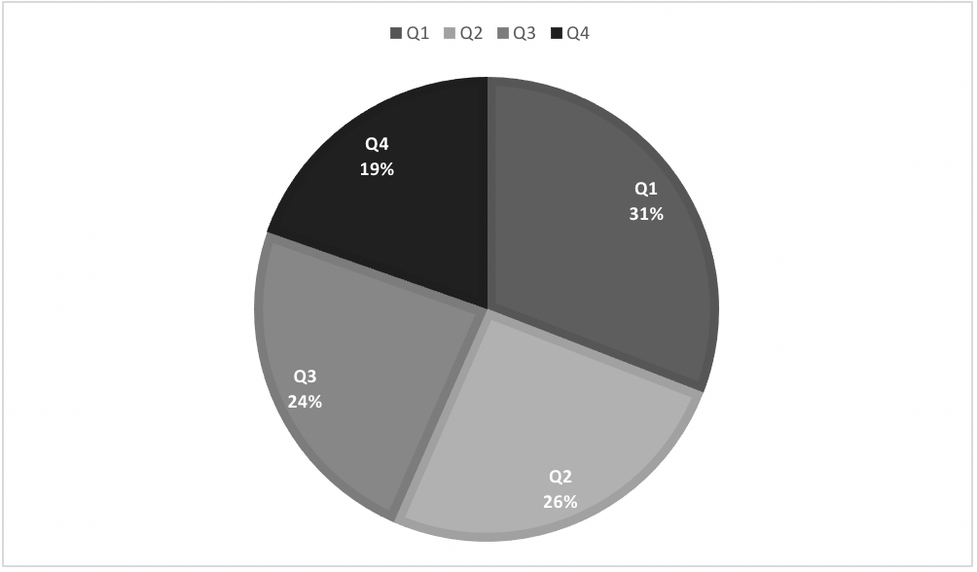

Figure 2 Distribution of players by quarter of birth in groups 1-5.
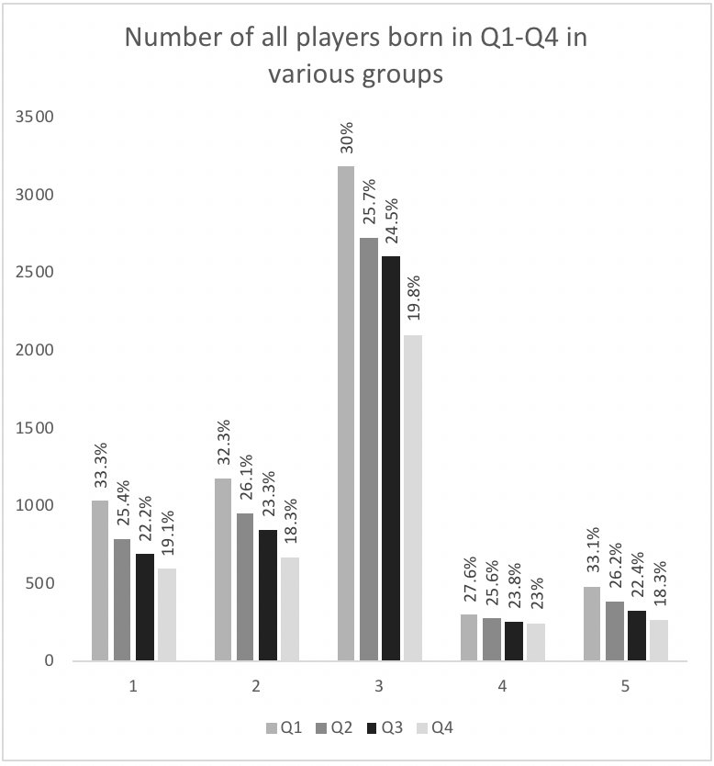
Figure 3. RAE by field position
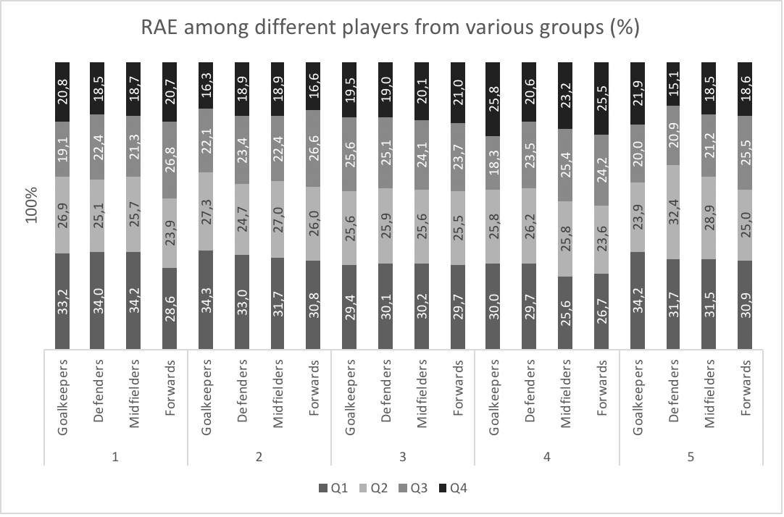

Figure 4. The association between player’s quarter of birth and market value.
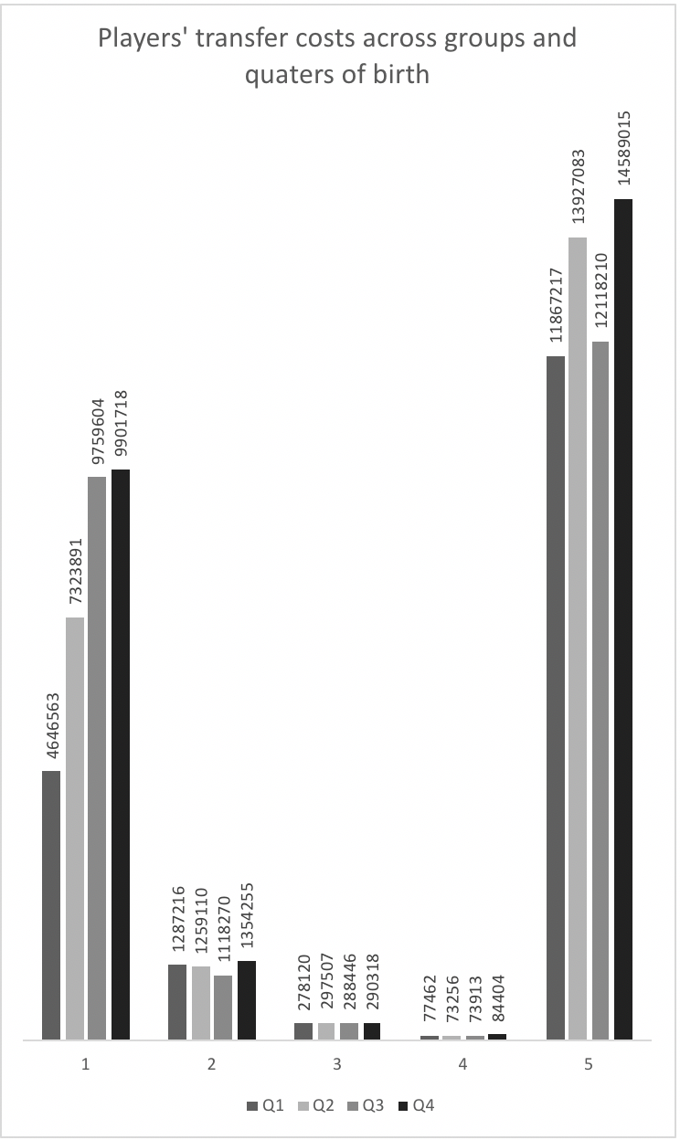

Figure 5. Relationship between the player’s field position and transfer fee


